Create a dockerfile, docker-compose file which when executed must display your basic details in the website.

First we did install the docker in instances after create a dockerfile for source code

Create a docker

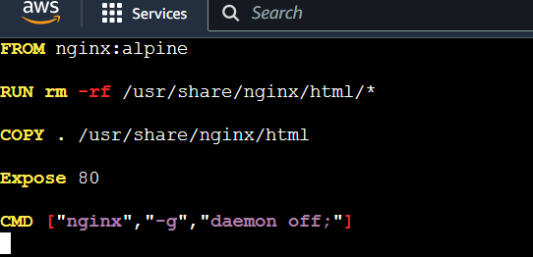

After ward create a docker-compose file for dockerfile to deployement source code

Create a Docker-compose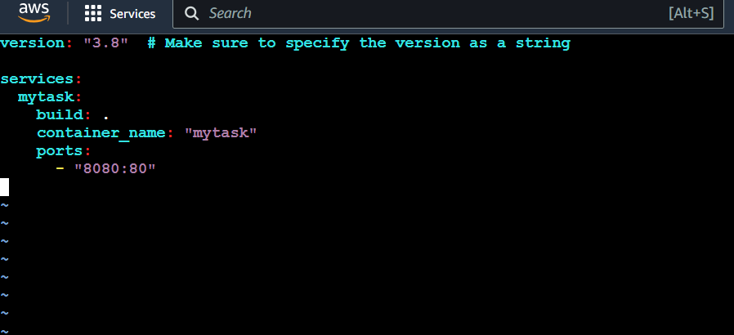

Afterward build file

Command for run Docker compose up -d

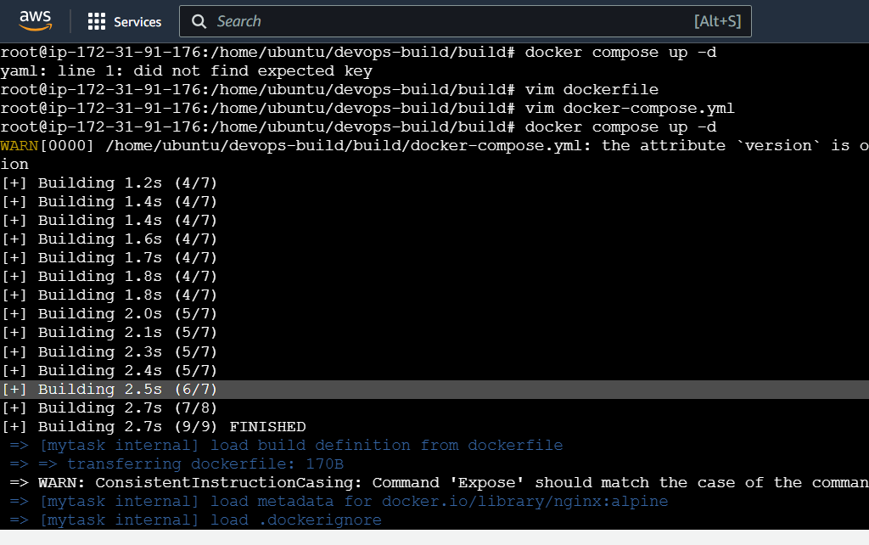

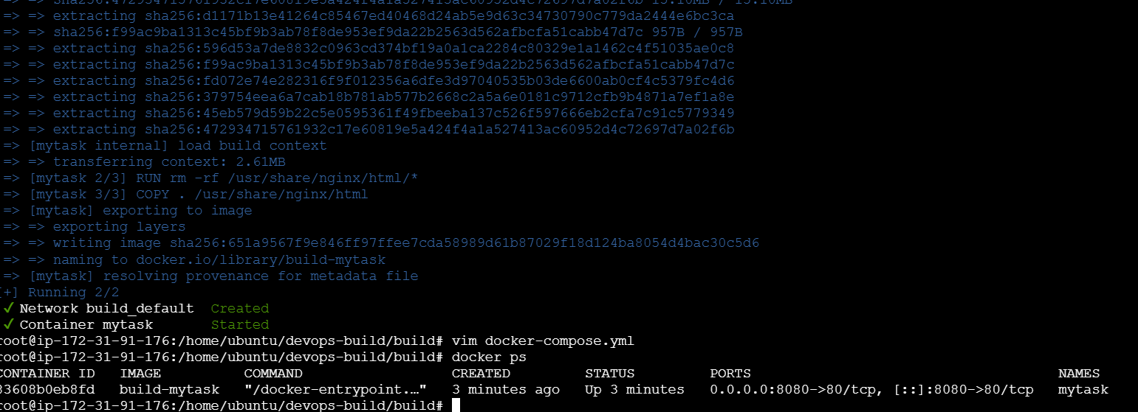

Now running application in container

To check <http://localhost:port>

